PurpleWASP
SOC 2 Implementation & Readiness Guide
End-to-end operating manual for organisations new to SOC 2 and for experienced compliance teams using PurpleWASP
Version 1.0 | September 2026
Product baseline: PurpleWASP SOC 2 Core v1 readiness workflow
Purpose
Use this guide to scope a SOC 2 engagement, select and operate controls, collect evidence, record tests, manage exceptions and issues, reach a documented readiness conclusion, and prepare for a CPA/service-auditor examination.

Document status, scope and important boundary
Important: PurpleWASP supports SOC 2 readiness; it does not issue a SOC 2 report.
A SOC 2 examination and report are performed by an independent CPA/service auditor under the AICPA SOC framework. PurpleWASP is the system of record for scoping, control coverage, implementation, assessments, evidence, testing, remediation and management/assessor readiness decisions.

This manual documents the current PurpleWASP SOC 2 user journey as implemented in the SOC 2 Core v1 workspace. It is deliberately written for a reader who may never have completed SOC 2 before. Technical database implementation, migrations and developer-level API details are outside the main user journey except where a product limitation materially affects how a user should interpret the screen.
The screen images in this guide are UI reference illustrations reconstructed from the current page structure and field names. They use sample data and are not captures from a live tenant. Replace them with production screenshots before publishing this document externally if exact tenant branding or data is required.
Document item | Value
Audience | Service-organisation management, compliance leads, control owners, assessors, evidence owners, security/IT teams and implementation consultants.
Primary objective | Move from initial SOC 2 scoping to a documented, defensible readiness state inside PurpleWASP.
Current product scope | Security baseline plus optional Availability, Processing Integrity, Confidentiality and Privacy; engagement scope; control mapping/selection; implementation; assessments; evidence; testing; issues/exceptions; control/criterion/engagement readiness.
External dependency | A qualified CPA/service auditor remains responsible for the SOC 2 examination and report.
Authoritative external basis | AICPA Trust Services Criteria, SOC 2 Description Criteria and SOC for Service Organizations guidance; see References.

How to use this guide
- If you are new to SOC 2: Read Chapters 1-4 before opening the setup workflow. They explain what the choices mean and what information to gather.
- If your organisation already has a SOC 2 programme: Start at Chapter 5 and use the page-by-page instructions to configure the current engagement.
- If you are preparing for a Type II examination: Pay particular attention to evidence source dates, validity windows and actual test execution timestamps. PurpleWASP intentionally separates "recorded in PurpleWASP" from "occurred during the observation period".
- If you are remediating gaps: Use Chapters 15-18 to trace blockers from operational readiness into issues, exceptions and management decisions.

Contents
1. SOC 2 primer for first-time users
2. PurpleWASP SOC 2 lifecycle at a glance
3. Roles and responsibilities
4. What to prepare before you start
5. Accessing the SOC 2 workspace
6. Setup Step 1 - Trust Services scope
7. Setup Step 2 - System boundary discovery
8. Setup Step 3 - Engagement and system scope
9. Setup Step 4 - Review and confirm
10. Using the SOC 2 Engagement Dashboard
11. Criteria / Control Readiness Matrix
12. Adopting controls and building the Control Coverage Plan
13. Control Implementation Workbench
14. Design and Operating Effectiveness Assessments
15. Evidence Requirements & Collection
16. Test Planning & Test Runs
17. Operational Readiness
18. Issues, Exceptions & Control Readiness Decisions
19. Engagement-Level Audit Readiness
20. Type I operating playbook
21. Type II operating playbook
22. Preparing for the service auditor
23. Example: first SOC 2 journey from zero to readiness
24. Recommended operating cadence
25. Common mistakes and how to correct them
26. Troubleshooting and interpretation guide
27. Master implementation checklist
28. Glossary
29. PurpleWASP page reference
30. References

1. SOC 2 primer for first-time users

1.1 What SOC 2 is
SOC 2 is an assurance reporting framework for service organisations. It evaluates controls relevant to one or more Trust Services Categories: Security, Availability, Processing Integrity, Confidentiality and Privacy. The service organisation describes the system that provides the service, defines the relevant commitments and system requirements, and presents controls designed to meet the applicable criteria. An independent CPA/service auditor examines that subject matter and issues the SOC 2 report.
Do not treat SOC 2 as a self-certification.
Your organisation can prepare, operate controls, collect evidence and assess readiness in PurpleWASP, but the final SOC 2 examination opinion comes from the service auditor.

1.2 Trust Services Categories
Category | What it means in plain language | PurpleWASP setup treatment
Security | Protection of systems and information against unauthorised access, use, disclosure or damage. | Always included as the baseline in the current setup workflow.
Availability | Whether systems and services are available for operation and use as committed. | Optional; include when availability, resilience, capacity or recovery commitments are in scope.
Processing Integrity | Whether processing is complete, valid, accurate, timely and authorised as required. | Optional; include when customers depend on processing correctness or completeness.
Confidentiality | Protection of information designated as confidential. | Optional; include when confidential-information commitments are material to the service.
Privacy | Collection, use, retention, disclosure and disposal of personal information against privacy commitments. | Optional; include when privacy-specific commitments are intended to be examined.

Scope discipline
PurpleWASP explicitly warns against selecting every optional category by default. Each additional category increases the criteria, evidence and testing that must be addressed.

1.3 Type I vs Type II
Report type | What is examined | When it is usually useful | PurpleWASP date input
Type I | Control design at a specified date. | An initial examination, a new system/control environment, or when operating history is not yet available. | Type I as-of date.
Type II | Control design and operating effectiveness over an observation period. | When stakeholders need evidence that controls operated over time, not only that they were designed. | Observation-period start and end; optional target report/examination date.

1.4 Five ideas you should understand before using the workspace
- Criterion: A requirement from the Trust Services Criteria. PurpleWASP shows the criterion code/title and maps candidate controls to it.
- Control: An organisation control that management operates. PurpleWASP can suggest candidate mappings, but management explicitly chooses which adopted controls it will rely on for each criterion.
- Evidence: A record or artefact that supports control design or operation. Evidence can be reusable and linked to multiple controls, but its temporal relevance must still be evaluated.
- Test: A planned procedure used to evaluate whether a control operated as intended. PurpleWASP separates reusable test definitions from individual completed test runs.
- Readiness decision: A management/assessor conclusion such as Ready, Conditionally Ready, Not Ready or Review Required. PurpleWASP recommendations are guidance; recorded decisions are separate and retain history.

1.5 System description, subservice organisations and CUECs
A SOC 2 engagement is about a defined system, not an entire company by default. The system boundary normally includes the people, processes, technology, data and relevant third-party dependencies used to provide the service. PurpleWASP therefore starts from business processes, discovers linked assets and third parties, and asks management to resolve the boundary explicitly.
- Subservice organisation: A third party whose services may be relevant to the system and the criteria. PurpleWASP asks management to decide whether an included/review provider is a subservice organisation and whether inclusive or carve-out treatment is expected.
- CUEC: A Complementary User Entity Control - a responsibility expected to be performed by the customer/user entity for the service organisation controls and system commitments to work as intended.
- Significant changes: Material changes to the system or control environment that should be considered in the engagement description and examination.
- Criterion exclusion/not-applicable rationale: A management planning judgement that needs specific rationale and later auditor validation; it should never be used merely to avoid a difficult control gap.

2. PurpleWASP SOC 2 lifecycle at a glance
The current SOC 2 workspace is organised as a sequence. The most reliable way to use it is to complete each layer before treating downstream readiness scores as meaningful.
Stage | PurpleWASP page | Purpose | Exit condition
1 | Scope Setup - Trust Services scope | Choose Security plus any justified optional categories. | Category selection is reviewed and carried into Step 2.
2 | System Scope Discovery | Select boundary-anchoring processes, discover assets/third parties, add scope-only items and resolve gaps. | No blocking or management-review scope gaps remain.
3 | Engagement & System Scope | Describe the service, users, report type/dates, subservices, CUECs and key judgements. | Completeness check passes and Step 3 is marked ready.
4 | Review & Confirm | Perform the final validation gate and create a confirmed engagement snapshot. | Confirmed SOC 2 configuration exists.
5 | Criteria Workspace | Review applicable criteria and mapped candidate/selected controls. | Coverage questions are understood and candidate controls are adopted where appropriate.
6 | Control Coverage Plan | Explicitly select adopted controls management will rely on. | Every applicable criterion has a defensible coverage plan.
7 | Implementation + Assessment | Document how selected controls operate and evaluate design/operating effectiveness. | Selected controls have current implementation records and appropriate final assessments.
8 | Evidence + Testing | Link current/period evidence and record test plans/runs. | Evidence and testing support the selected control population and, for Type II, the observation period.
9 | Operational Readiness + Remediation | Review signals; create issues/exceptions; record control decisions. | Material control blockers are resolved, accepted with rationale, or explicitly not ready.
10 | Audit Readiness | Record criterion decisions and the engagement decision. | All applicable criteria and the engagement have an explicit, defensible decision.

Recommended order
Do not jump directly to Audit Readiness. A green or red conclusion only becomes meaningful after management has confirmed scope, selected coverage controls, documented implementation, and populated the underlying assessment/evidence/testing signals.

3. Roles and responsibilities
Role | Typical responsibilities in PurpleWASP
Executive / service owner | Approves the system scope, service commitments, material judgements, subservice/CUEC decisions and final readiness position.
Compliance manager / SOC 2 lead | Runs the setup workflow, coordinates control mapping, monitors readiness, manages evidence cadence and prepares the organisation for the service auditor.
Control owner | Accountable for the control objective and ongoing operation; reviews implementation, evidence, test failures, issues and exceptions.
Implementation owner | Maintains the operational procedure/technology that implements the control and updates the implementation statement when the control changes.
Assessor / reviewer | Performs design and operating assessments, records results, coverage/confidence and assessment notes, and contributes to readiness decisions.
Evidence owner / system administrator | Collects or links evidence with accurate source timestamps, validity dates, source systems and storage references.
Test owner | Maintains the test definition and records actual test runs with the real execution/completion timestamp.
Risk owner | Owns related risks and may be selected from Risk Management when an exception or issue is tied to an existing risk.
CPA/service auditor | Independent external party responsible for the SOC 2 examination and report; may request additional evidence, sampling and clarifications outside the PurpleWASP readiness model.

4. What to prepare before you start

4.1 Minimum organisational data
- Current list of business processes that contribute to the service.
- Asset inventory for the service: cloud subscriptions, production environments, applications, databases, endpoints, infrastructure and other in-scope technology.
- Third-party/vendor records and the specific services they provide.
- Current user/principal catalogue so management and control owners can be assigned.
- Control Management library with organisation controls where possible.
- Risk register entries for material security/service risks.
- Policy and procedure records relevant to the service.
- An initial view of which customers, customer auditors, regulators, partners or governance bodies are intended users of the report.

4.2 Decisions to discuss before setup
Decision | Questions to answer
Service boundary | Which product/service will the report cover? Is this one service, a platform, a region, or a broader system?
Trust Services scope | Beyond Security, do contracts or customer promises require Availability, Processing Integrity, Confidentiality or Privacy?
Type I or Type II | Do stakeholders need a point-in-time design report or evidence of operating effectiveness across a period?
Observation period | If Type II, what period is realistic given current operating history and evidence availability?
Subservice organisations | Which third parties are relevant to the system and should be discussed with the service auditor as carve-out/inclusive candidates?
CUECs | What responsibilities must customers perform for the service to remain secure/reliable as designed?
Target examination timing | When do customers need the report, and when should fieldwork begin?

4.3 Readiness of your Control Management data
PurpleWASP SOC 2 intentionally reuses the organisation control model. Candidate mappings do not automatically become SOC 2 coverage. Controls normally need to be adopted into Control Management before they can be selected as organisation coverage. This separation is important: a candidate mapping is a suggestion; a selected organisation control is management’s actual coverage decision.
Do not seed readiness state directly in the database.
Use PurpleWASP application workflows for adoption, coverage, assessments, evidence, testing, issues, exceptions and decisions. Direct database edits bypass validation, audit history and supersession logic.

5. Accessing the SOC 2 workspace
1. Open Compliance. Use the PurpleWASP main navigation and select the Compliance module.
2. Choose the framework. In the compliance framework picker, choose SOC 2. ISO 27001 remains a separate framework workspace.
3. Confirm you are in the SOC 2 side menu. The left-hand navigation should show SOC 2 Dashboard, Scope & Criteria, Controls & Testing, Remediation and Audit Readiness.
4. If no engagement is confirmed yet, start Scope Setup. The dashboard will show a "No confirmed SOC 2 engagement yet" state with a setup action.
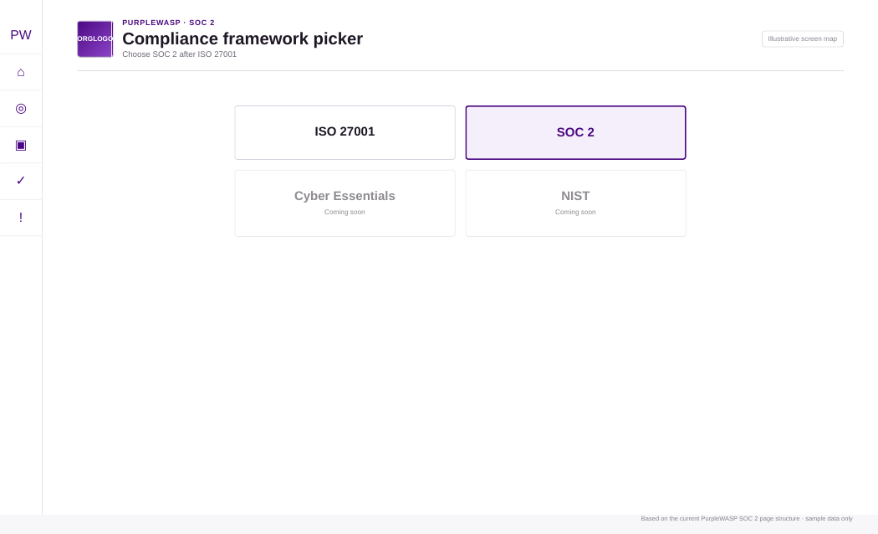
Figure 1. Illustrative framework picker. SOC 2 is selected as a separate compliance workspace.

SOC 2 navigation map
Menu group | Pages
Dashboard | SOC 2 Dashboard
Scope & Criteria | Scope Setup; Criteria Workspace
Controls & Testing | Control Coverage Plan; Implementation Workbench; Control Assessments; Tests & Monitoring; Evidence; Operational Readiness
Remediation | Issues, Exceptions & Decisions
Final readiness | Audit Readiness

6. Setup Step 1 - Trust Services scope
Goal: decide which Trust Services Categories belong in the intended SOC 2 examination scope. PurpleWASP treats Security as the baseline and lets management add optional categories only where they are justified by the service and its commitments.
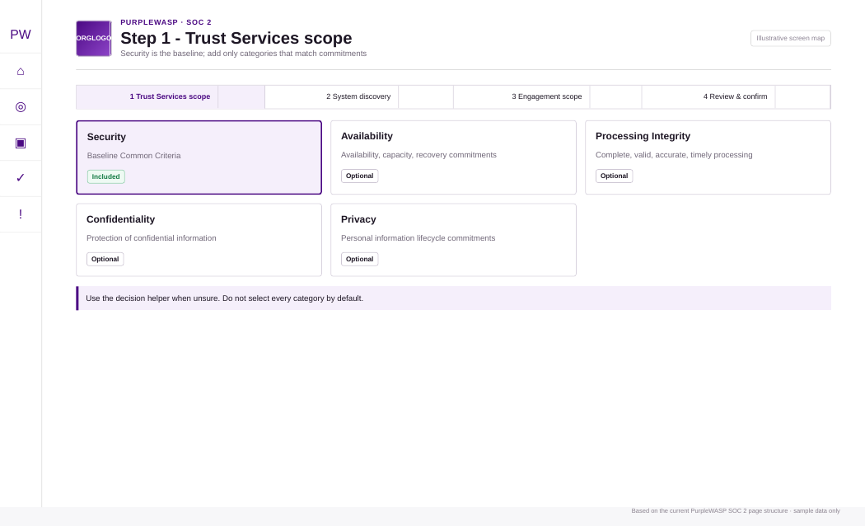
Figure 2. Illustrative Trust Services scope screen. Security is the required baseline; additional categories are optional.

6.1 Step-by-step
1. Review the "Before choosing Trust Services Categories" guidance. Do not treat the category list as a maturity checklist. The question is what the intended SOC 2 examination needs to cover.
2. Keep Security selected. The current PurpleWASP workflow includes Security as the baseline and carries the Common Criteria into the engagement.
3. Review Availability. Select it when the service has relevant availability, capacity, uptime, recovery or resilience commitments that stakeholders expect to be examined.
4. Review Processing Integrity. Select it when the service promises processing that must be complete, valid, accurate, timely or authorised.
5. Review Confidentiality. Select it when information designated as confidential is materially in scope.
6. Review Privacy. Select it when personal-information privacy commitments and lifecycle obligations are intended to be examined.
7. Use the Decision Helper when uncertain. The helper changes the preview only; it does not commit the configuration.
8. Refresh the preview. Review the expected criterion/control impact before continuing.
9. Continue to System Scope Discovery. The selected categories are carried into Step 2 as a browser-session draft until final confirmation.
Confidentiality is not the same as Privacy.
Confidentiality concerns information designated as confidential. Privacy concerns personal information and privacy commitments across its lifecycle. A service can need one, both or neither beyond the Security baseline.

6.2 What to record in your implementation notes
- Why each optional category was selected.
- Which customer contract, service promise, regulatory expectation or internal system requirement supports the decision.
- Any category discussed but intentionally not selected, together with the reason.

7. Setup Step 2 - System boundary discovery
Goal: turn PurpleWASP organisational data into a proposed SOC 2 system boundary, then make management’s inclusion/review/exclusion decisions explicit. This is one of the most important stages because every later control, evidence and test conclusion depends on what system is actually in scope.
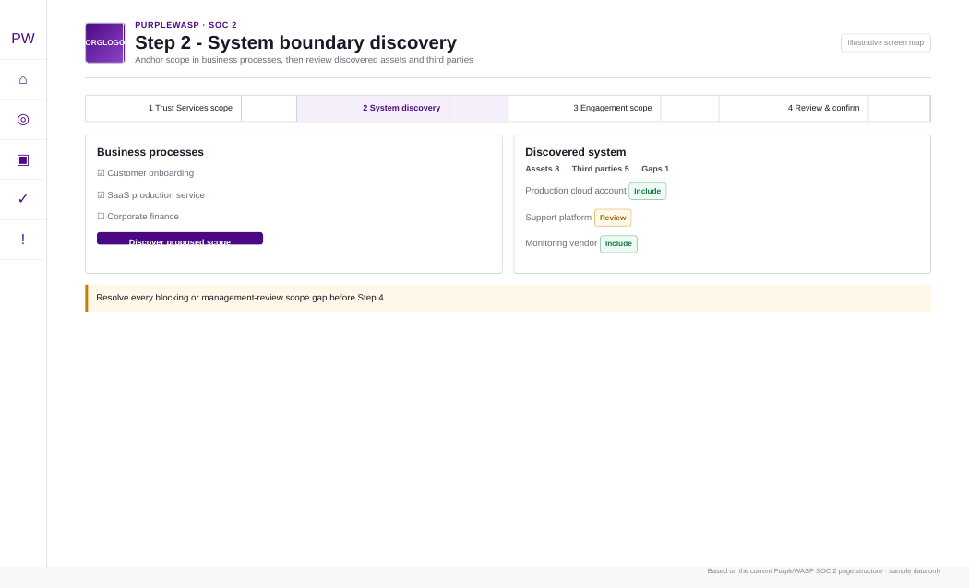
Figure 3. Illustrative system discovery screen showing process anchors, discovered assets/third parties and gap review.

7.1 Select the business processes that anchor the boundary
1. Choose processes that actually deliver or support the service. Examples may include production operations, customer onboarding, access administration, support, incident response and change management.
2. Avoid selecting unrelated corporate processes merely because they exist. Scope should be defensible and tied to the service under examination.
3. Add a scope-only process if PurpleWASP does not yet know about a material process. Use the Add scope-only item workflow rather than pretending an unrelated existing process is the correct anchor.

7.2 Discover the proposed system
Run discovery after selecting the process anchors. PurpleWASP uses available relationships to propose assets, third parties/services and supporting information such as controls, risks and policies. Trust Services Category signals are advisory; they do not replace management’s scope judgement.

7.3 Review every discovered object
Decision | Use it when | Documentation expectation
Include | The object is part of the system or materially supports delivery of the scoped service. | Record/include it in the boundary.
Review | Management has not resolved whether it belongs in scope. | Do not leave this unresolved at confirmation; investigate ownership, relationship or service dependency.
Exclude | The object was discovered through a relationship but is not part of the scoped system. | Provide a specific rationale. Exclusions without rationale are blocked at confirmation.

7.4 Resolve data-quality and scoping gaps
The final confirmation endpoint recomputes the live boundary on the server. Browser counters are not trusted as the final gate. Blocking gaps and management-review gaps must be resolved before confirmation.
- A discovered asset that still needs a scope decision.
- An included third party that does not have a supporting service resolved.
- A scope-only item that needs a decision or a clearer relationship.
- An exclusion that lacks rationale.
- A relationship that changed after discovery and needs the scope to be re-run.
Exit criterion for Step 2
Do not proceed merely because the screen looks complete. The final gate expects zero blocking gaps and zero management-review gaps, and it rechecks the live scope at confirmation.

8. Setup Step 3 - Engagement and system scope
Goal: describe the service and the intended examination in terms that management and the service auditor can understand, while carrying forward the reviewed system boundary from Step 2.
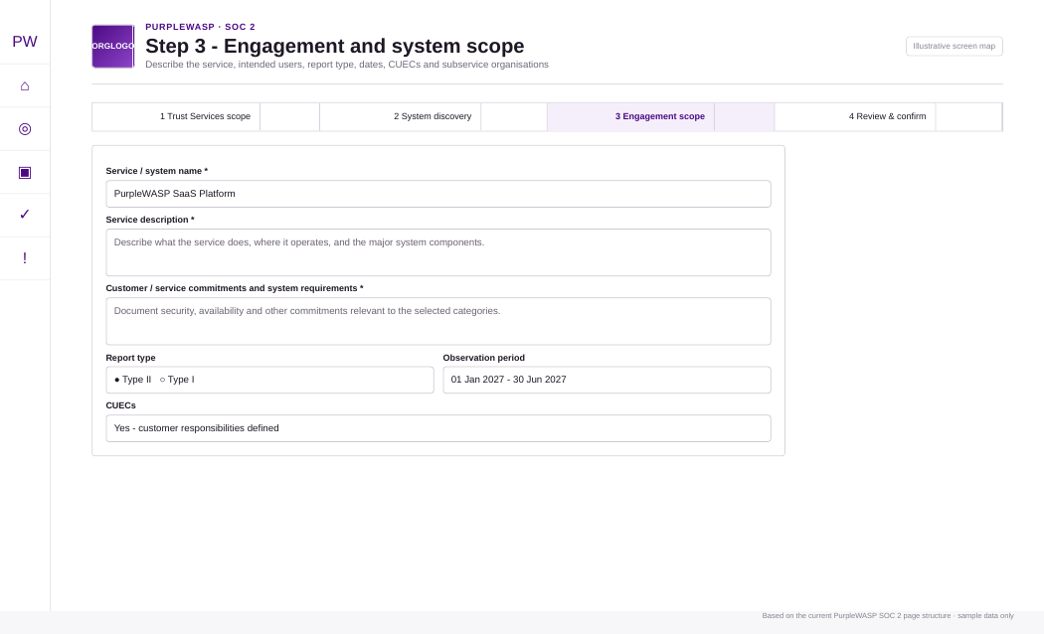
Figure 4. Illustrative engagement scope screen. Service description, report type/period, subservice decisions and CUECs are part of the completeness gate.

8.1 Describe the service
Field | How to complete it
Service / system name * | Use the name stakeholders recognise. Avoid an internal project nickname if customers know the service by another name.
Management owner / accountable function | Choose the accountable user or organisation role where available.
Service description * | Describe what the service does, the main user/customer interaction, major processing/components, and the system being put forward for examination.
Customer / service commitments and system requirements * | Describe promises and requirements that drive control design: security commitments, availability targets, confidentiality handling, processing obligations, privacy commitments, etc.
Commitment sources / references | Reference contracts, SLAs, policy statements, terms, architecture requirements or other sources used to derive the commitments.

8.2 Identify intended report users
PurpleWASP requires at least one intended-user group or a populated "Other intended users" field. The allowed groups in the current confirmation logic include existing customers, prospective customers, customer auditors, regulators, business partners and internal governance.

8.3 Choose Type I or Type II and dates
1. Choose Type I or Type II. "Undecided" is available while planning, but final confirmation requires Type I or Type II.
2. For Type I, enter the as-of date. The current confirmation gate requires the date.
3. For Type II, enter observation-period start and end. The start cannot be after the end.
4. Optionally enter a target report/examination date. Use this for programme planning; it is not the same as the Type II observation period.

8.4 Review potential subservice organisations
For each included/review third party carried from Step 2, first ensure a supporting service has been resolved. Then choose a treatment and write the rationale. The current options are: Subservice organisation - carve-out method; Subservice organisation - inclusive method; Not treated as a subservice organisation; or Undecided while planning. Final readiness for Step 3 does not accept unresolved treatment/rationale.
Do not let PurpleWASP make the judgement for you.
The product can explain why the provider was discovered, but management and the service auditor must decide whether it is a subservice organisation and whether carve-out or inclusive treatment is appropriate.

8.5 Define CUECs
1. Decide whether CUECs apply. Final confirmation requires Yes or No; Undecided is a planning state only.
2. If Yes, add at least one complete CUEC. Each CUEC needs a customer/user-entity responsibility title and description.
3. Associate the CUEC with relevant selected categories. This helps keep the responsibility tied to the scope it supports.
4. Write responsibilities as actions the customer must perform. For example, promptly removing access for terminated personnel is clearer than "customers must be secure."

8.6 Significant changes and criterion exclusions
For both significant changes and criterion-exclusion planning, final confirmation expects an explicit Yes or No. If Yes, PurpleWASP requires details. A proposed criterion exclusion is a planning record for final auditor validation; it is not an automatic removal of a criterion merely because management prefers not to address it.

8.7 Run the completeness check
Completeness row | What must be true
Step 2 system boundary | No blocking/review boundary gaps remain.
Service description & commitments | Service name, description and commitments are populated.
Intended report users | At least one group or other-user description is populated.
Examination type & period | Type I with as-of date, or Type II with valid start/end.
Subservice treatment | Every relevant provider has a resolved service, treatment and rationale.
CUECs | No, or Yes with at least one complete CUEC.
Significant changes | Explicit Yes/No; details if Yes.
Criterion exclusion planning | Explicit Yes/No; details if Yes.

When all required rows are satisfied, choose Check & mark draft ready, then open Step 4 - Review & confirm.

9. Setup Step 4 - Review and confirm
Goal: perform a final management review and create the confirmed SOC 2 engagement snapshot. Earlier confirmed engagements remain preserved; a later confirmation creates a new snapshot rather than silently rewriting history.
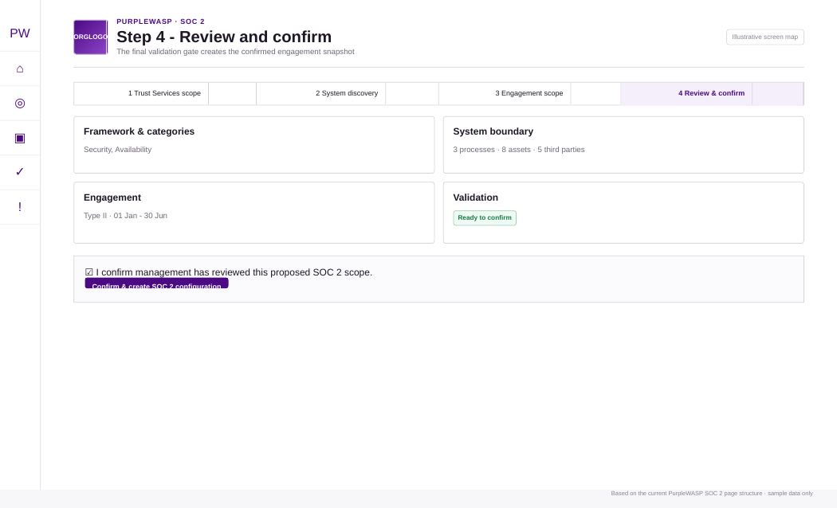
Figure 5. Illustrative final validation gate before PurpleWASP creates the confirmed SOC 2 engagement snapshot.

9.1 What the final gate revalidates
- The Trust Services category scope still matches what was carried through Step 2.
- Steps 2 and 3 exist and Step 3 is marked ready.
- The live system-boundary discovery has no blocking or management-review gaps.
- Every exclusion has rationale and no unresolved review objects remain.
- Service name, description and commitments are present.
- At least one intended report-user group is present.
- Report type is Type I or Type II and required dates are valid.
- CUEC applicability is Yes or No; if Yes, at least one complete CUEC exists.
- Significant-changes and criterion-exclusion decisions are complete.
- Subservice treatment decisions are valid for the live included/review third-party population.

9.2 Confirm the configuration
1. Review Framework and Trust Services scope. If wrong, return to Step 1 instead of fixing downstream records around a bad scope.
2. Review System boundary. Make sure process, asset and provider counts reflect the intended service.
3. Review Engagement summary. Check type, period, users, commitments and key judgements.
4. Review subservice organisations, CUECs and criterion applicability. These are engagement-specific judgements and will be snapshotted.
5. Tick the management confirmation statement. This records that management reviewed the proposed scope.
6. Choose Confirm & create SOC 2 configuration. PurpleWASP creates the engagement snapshot and enables the downstream criteria/control readiness workflow.
Treat confirmation as a controlled baseline.
After confirmation, use the operational workspaces to improve readiness. If the fundamental service/system scope changes materially, create a deliberate new configuration snapshot rather than quietly treating the original snapshot as if it had always included the change.

10. Using the SOC 2 Engagement Dashboard
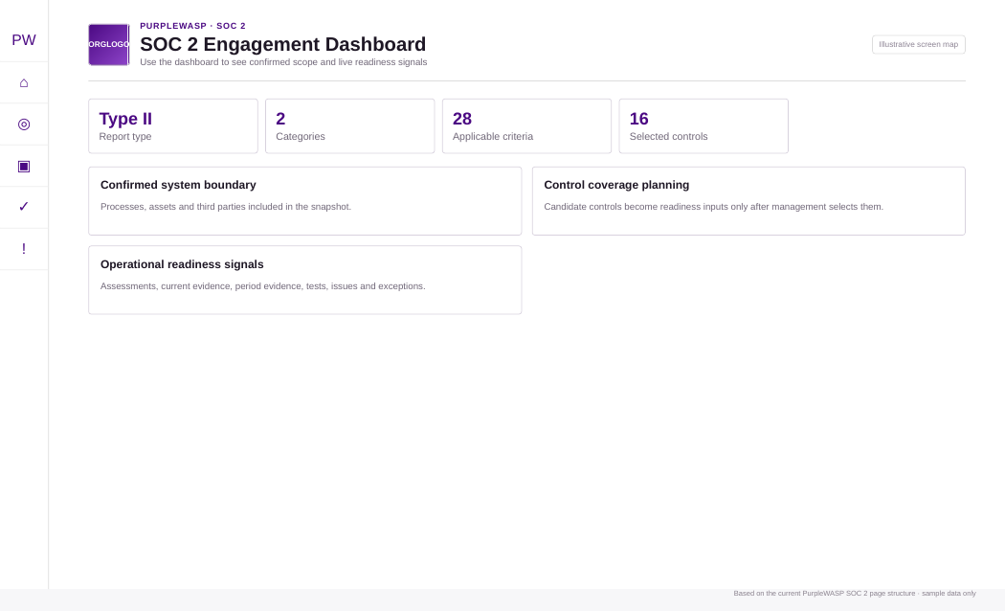
Figure 6. Illustrative Engagement Dashboard showing the confirmed boundary, control coverage and live readiness signals.
The dashboard is the entry point after confirmation. It is not a substitute for the detailed workbenches; it tells you where to go next.

10.1 Read the engagement identity first
- Confirm the engagement code/system name is the one you intend to work on.
- Confirm the Type I as-of date or Type II observation period.
- Confirm the selected Trust Services Categories.
- Confirm the system-boundary counts before interpreting control readiness.

10.2 Use the three dashboard sections
Section | Interpretation | Typical next action
Confirmed system boundary | The snapshotted scope from setup. | If fundamentally wrong, revisit setup/configuration rather than compensating with control data.
Control coverage planning | Whether management has moved from candidate mappings to explicit selected organisation controls. | Open Criteria Workspace and Control Coverage Plan.
Operational readiness signals | Live status from implementation, assessments, evidence, testing, issues and exceptions for selected controls. | Open Operational Readiness and the relevant workbench for the blocker.

11. Criteria / Control Readiness Matrix
Goal: understand each applicable criterion, the candidate PurpleWASP control mappings, the organisation controls already selected, and the current readiness status. The current UI keeps each criterion compact and collapses the detailed control list until you choose View controls.
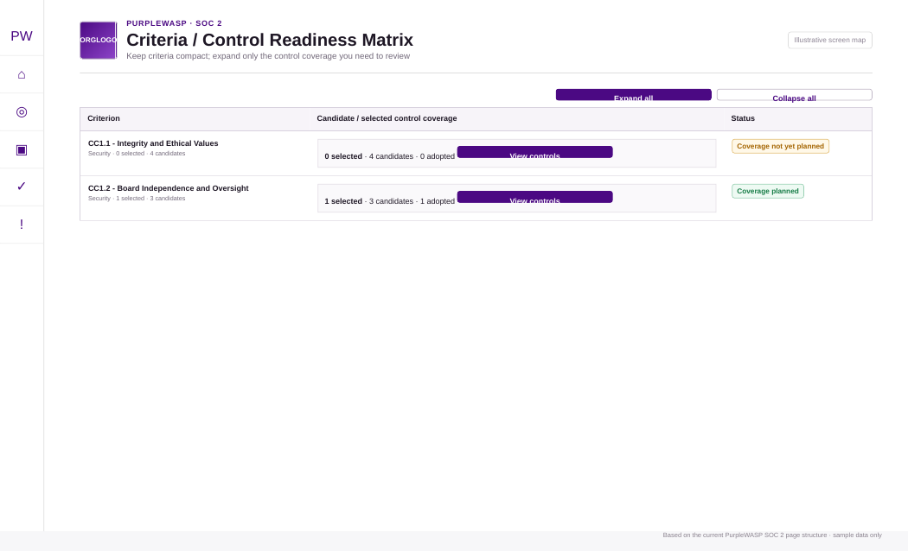
Figure 7. Illustrative collapsible Criteria / Control Readiness Matrix.

11.1 Read a criterion row
Item | Meaning
Criterion code/title | The Trust Services criterion in the confirmed engagement.
Category | The selected Trust Services Category that brought the criterion into scope.
Selected count | Organisation controls management has explicitly selected for this criterion.
Candidate count | PurpleWASP candidate mappings available for consideration.
Adopted candidate count | Candidate controls already adopted into the organisation Control Management model.
Status | Current criterion readiness/coverage status derived from the underlying state.

11.2 Expand controls only when you need detail
1. Choose View controls. The row expands inline instead of making the whole matrix permanently tall.
2. Review each candidate control. Check code/name, domain, mapping strength and whether the control is already adopted.
3. If not adopted, choose Review / adopt. This moves the decision into Control Management; adoption is not the same as SOC 2 coverage selection.
4. If adopted, use Manage coverage decision. This takes you to the Control Coverage Plan for the explicit criterion-to-control selection.
5. If selected, open Implementation Workbench. This is where the actual organisation-control operation is documented.
Candidate is not selected.
A candidate mapping remains advisory. It does not enter the readiness conclusion merely because PurpleWASP knows the control could support the criterion.

12. Adopting controls and building the Control Coverage Plan
Goal: explicitly identify the organisation controls management intends to rely on for each criterion. The coverage plan is the bridge between the framework and your operational Control Management records.
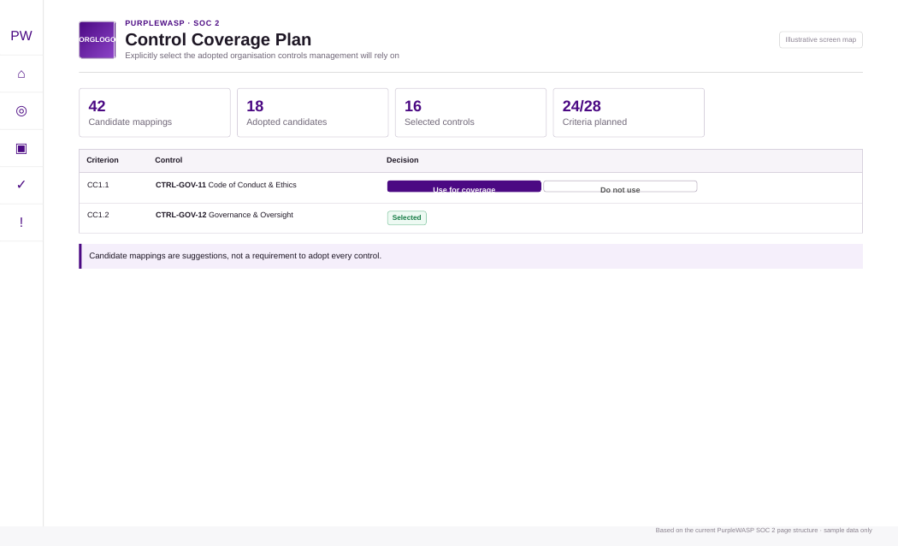
Figure 8. Illustrative Control Coverage Plan. Management selects adopted organisation controls; candidate mappings remain advisory.

12.1 Adopt a control before selecting it
1. From Criteria Workspace, open Review / adopt for a candidate that your organisation actually uses or intends to use. Do not adopt controls simply to make a criterion look covered.
2. Complete the Control Management adoption workflow. The adopted control becomes an organisation control that can carry implementation, evidence, tests, issues and ownership.
3. Return to the coverage plan. The adopted candidate can now be selected as SOC 2 coverage.

12.2 Record the coverage decision
Action | Meaning | When to use it
Use for coverage | Management intends to rely on the organisation control for the criterion. | The control genuinely addresses all or part of the criterion and will be operated/tested.
Do not use | The candidate mapping is known but management will not rely on this control for this criterion. | Another control or control combination is the intended coverage, or the candidate is not appropriate for this service.
Clear decision | Return the candidate to unreviewed. | You need to reconsider rather than preserve a selected/excluded decision.

Selected + Not Applicable is intentionally blocked.
PurpleWASP does not allow a control that is selected for SOC 2 coverage to be marked Not Applicable in the implementation workbench. First change the coverage decision, then change applicability if that is genuinely the right conclusion.

12.3 Aggregate/multiple-control coverage
Some criteria need more than one organisation control. Where the criterion is treated as aggregate/multiple-control coverage, evaluate the control set together. Do not force one control to carry claims that are actually delivered by a combination of governance, technical and operational controls.

12.4 Coverage-plan completion test
- Every applicable criterion has at least one defensible selected control or an appropriately supported coverage approach.
- Selected controls are adopted and operationally relevant to the confirmed system boundary.
- Controls you explicitly do not rely on are marked accordingly rather than left ambiguous.
- Any Not Applicable planning judgement is supported by rationale and is not being used to bypass a known gap.

13. Control Implementation Workbench
Goal: document how each selected organisation control actually operates in the scoped service. This is where a framework mapping becomes an operational control story that can be assessed, evidenced and tested.
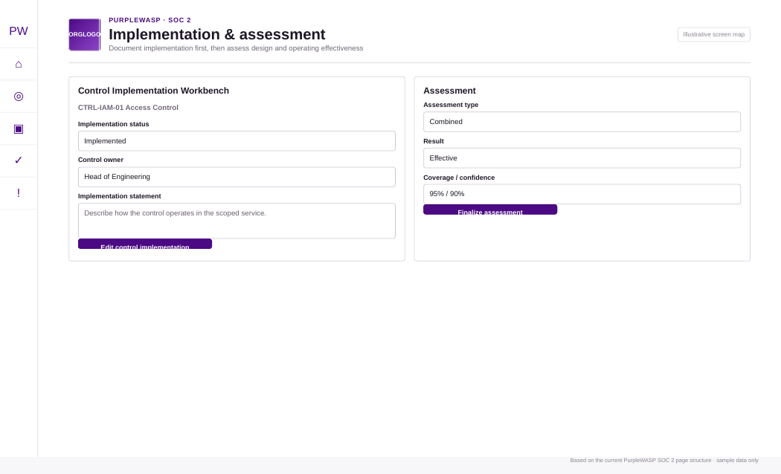
Figure 9. Illustrative implementation and assessment workbenches.

13.1 Complete the control-level implementation record
Field | Allowed/current choices | Guidance
Applicability | Applicable; Under Review; Not Applicable | A selected SOC 2 coverage control cannot be changed to Not Applicable until coverage selection is removed.
Requirement level | Required; Recommended; Optional | Use your organisation’s actual governance treatment; this is not a replacement for criterion applicability.
Implementation status | Not Implemented; Planned; Partially Implemented; Implemented | Choose the state that reflects current operation, not the target state.
Control owner | PurpleWASP user/principal | Accountable for the control.
Implementation owner | PurpleWASP user/principal | Person who maintains the process/technology.
Review frequency | 1-120 months | How often the implementation should be formally reviewed.
Next review date | Date | Use to establish an operating cadence.
Implementation statement | Free text | Describe systems/processes, responsibilities and key operating steps in enough detail that an assessor can understand how the control works.

13.2 Use the control objective and description as context
The objective/description section is intentionally collapsible. Read it before editing the implementation statement, but write the implementation statement in organisation-specific language. Repeating the generic control description is not evidence that the control exists.

13.3 Record asset-specific implementation where relevant
If a control operates differently by asset, use the scoped asset implementation section. The asset record can carry its own applicability, requirement, implementation status and notes. This lets a control be implemented on one scoped asset but still under review on another without losing the control-wide context.
Implementation statement quality test
A new assessor should be able to answer: who performs the control, what exactly they do, which systems/processes are involved, how often it happens, what output is produced, and what happens when the control fails.

14. Design and Operating Effectiveness Assessments
Goal: record an assessment conclusion separately from the implementation statement. PurpleWASP supports control-wide or asset-specific assessment context and Design, Operating or Combined assessment types.

14.1 Choose the assessment scope
- Control-wide: Use when the assessment conclusion applies to the control across the scoped implementation.
- Asset-specific: Available only where an explicit active asset implementation row exists. Use when effectiveness differs materially by asset.

14.2 Choose the assessment type
Type | Question being answered | Percentage fields
Design | Is the control suitably designed to address the intended objective/criterion? | Design effectiveness shown; operating effectiveness hidden/disabled.
Operating | Did the control operate as intended during the relevant period or sample? | Operating effectiveness shown; design effectiveness hidden/disabled.
Combined | What is the combined conclusion across design and operation? | Both design and operating fields may be used, plus overall effectiveness.

14.3 Complete the assessment record
Field | Current options / meaning
Method | Self; Independent; Automated; Hybrid.
Result | Not determined; Effective; Partially effective; Ineffective.
Assessed at | When the assessment was performed.
Valid until | Optional date for the expected currency of the assessment.
Design / Operating / Overall effectiveness % | Quantitative judgement where your methodology uses percentages.
Coverage % | How much of the intended population/scope the assessment covered.
Confidence % | Assessor confidence in the conclusion; document the basis in notes.
Assessment notes | Procedures performed, evidence reviewed, observations, limitations and conclusion.

14.4 Draft vs final
1. Use Save draft while work is incomplete. Draft assessments should not be treated as final readiness evidence.
2. Use Finalize assessment when the assessor is prepared to stand behind the conclusion. Operational readiness counts controls with at least one final assessment.
3. Reassess after material control changes or when validity expires. Keep history rather than overwriting the conceptual audit trail.

15. Evidence Requirements & Collection
Goal: link reusable evidence records to selected controls while preserving what the evidence is, where it came from, what period it relates to and why it supports the control.
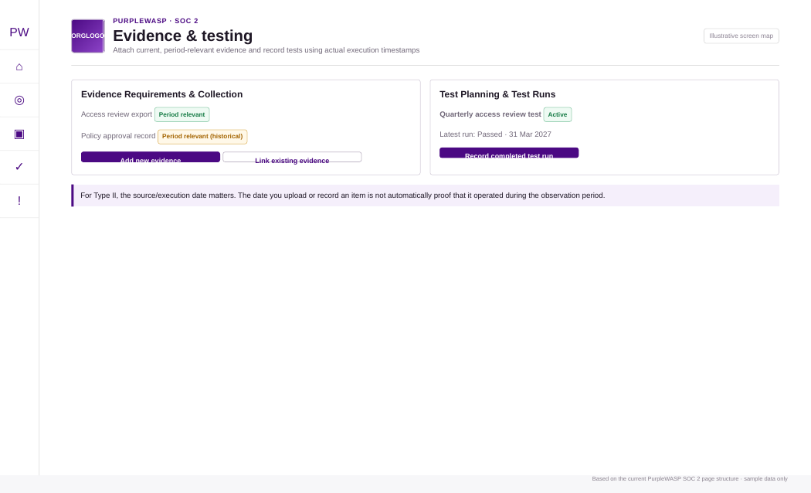
Figure 10. Illustrative Evidence and Testing workbenches. Temporal classification is intentionally separate from the date the item was added to PurpleWASP.

15.1 Understand the evidence model
- Evidence record: The reusable item - title, description, type, source, source timestamp, validity, storage reference, URL and status.
- Evidence link: The relationship between that evidence item and a control - purpose, scoped asset and link notes.
- Unlink: Removes only the control relationship; it does not delete the reusable evidence record.
- Edit existing evidence: Changes the reusable record everywhere it is linked. PurpleWASP warns you about this shared-record behaviour.

15.2 Add new evidence
1. Choose Add new evidence. The form opens in the SOC 2 modal workspace.
2. Enter Evidence title. Use a human-readable name that an assessor can recognise.
3. Choose Evidence type and Source type. Use the values configured by your Control Management evidence schema.
4. Choose Evidence status. Do not keep revoked/archived evidence as if it were current support.
5. Enter Source system. Examples: identity provider, ticketing platform, cloud provider, HR system, vulnerability scanner.
6. Enter Evidence/source timestamp when the underlying event or record occurred. This is different from when the file is uploaded to PurpleWASP.
7. Enter Valid from / Expires at when the evidence represents a period. For example, a policy approval may remain valid until the next scheduled review; a certificate may have explicit validity dates.
8. Enter Storage reference and/or External URL. Point to the controlled location of the source evidence.
9. Choose Link purpose. Current allowed purposes include general, supports design, supports operation, test artefact, exception support and issue support.
10. Choose a scoped asset if the evidence is asset-specific. Otherwise leave it control-wide.
11. Write Link notes. Explain why this item supports this control/criterion.
12. Create & link evidence. The record is created and immediately linked to the selected control.

15.3 Link existing evidence
Use Link existing evidence when the same evidence already exists in Control Management. This avoids duplicates and lets one artefact support more than one control where that is genuinely appropriate. Reuse does not remove the need to explain the link purpose.

15.4 Temporal classifications you will see
Label | Meaning | How to interpret it
Period relevant | Current evidence whose source/validity interval overlaps the engagement window. | Potentially useful current support for a Type II observation period.
Period relevant (historical) | The item overlaps the period but is no longer current (for example expired/stale). | Historical period relevance does not make it current readiness evidence.
Outside engagement period | Known dates do not overlap the engagement period. | May still be useful context, but do not treat it as period proof.
Temporal basis unknown | No sufficient source/validity date is recorded. | Fix the metadata before relying on it for period conclusions.

Type II evidence rule
The upload/record-created timestamp is not automatically evidence that the control operated during the observation period. Use the underlying source timestamp and/or validity interval.

16. Test Planning & Test Runs
Goal: define reusable test procedures for selected controls and record individual executions without overstating what a single test run proves about a Type II observation period.

16.1 Create or edit a test plan
Field | Guidance
Test name * | Describe the control behaviour being tested.
Method | Current fallback methods include Manual, Automated and Hybrid; use the configured schema value.
Cadence | Use the configured cadence or a clear value such as monthly, quarterly, annual or continuous.
Severity | Low, Medium, High or Critical impact if the test fails, subject to the configured schema.
Scoped asset | Leave control-wide unless the test relates to a specific active asset implementation.
Test owner | Assign the person responsible for executing/reviewing the test.
Source system / External test key | Use these to tie the test to an integration, scanner, ticket, script or external system.
Next due | Maintain cadence and overdue visibility.
Test procedure | Write the actual steps/sample approach.
Expected result | Define what pass/effective operation looks like before execution.

PurpleWASP may show suggested tests to consider. They are guidance-only starting points, not mandatory auditor procedures. Management/assessors remain responsible for final test design, sample, cadence and conclusion.

16.2 Record a completed test run
1. Open Record completed test run. Do this against the correct test definition.
2. Choose Result. Current fallback results include Passed, Failed, Error, Not Applicable and Inconclusive.
3. Choose Execution source. Current fallback values include Manual, Integration, Scheduler and Import.
4. Enter Started at if useful. This helps document run duration/context.
5. Enter Completed / execution timestamp. Use when the test actually executed, not when you record it in PurpleWASP.
6. Enter Source run key. Tie the run to the underlying job/ticket/integration when available.
7. Write Result summary. Capture exceptions, sample size, failures and follow-up.

16.3 Type II period interpretation
Badge | Meaning
Executed in period | The recorded execution timestamp is within the Type II observation period.
Outside engagement period | The execution timestamp is known and outside the observation period.
Execution period unknown | The timestamp is insufficient to classify the run.

Do not infer whole-period coverage from one timestamp.
The current test-run model identifies when a run executed; it does not store explicit coverage start/end dates for the population. A single retrospective run outside the period is not automatically proof that the control operated throughout the period.

17. Operational Readiness
Goal: review the operational signals for every management-selected coverage control and use the detail to decide what work is still required.
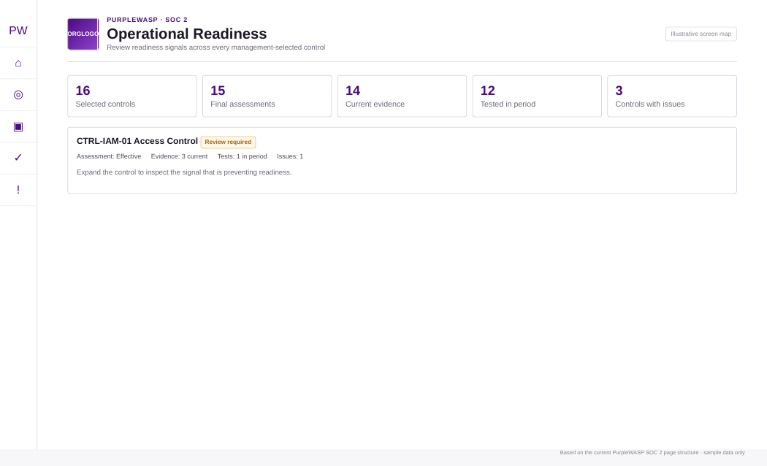
Figure 11. Illustrative Operational Readiness summary and per-control signal review.

17.1 Read the summary metrics
Metric | What it tells you
Selected coverage controls | How many distinct organisation controls management has selected for SOC 2 coverage.
Final assessments | Controls with at least one final assessment.
Current evidence | Controls with current linked evidence.
Period-relevant evidence | Controls with evidence whose source/validity overlaps the engagement window.
Active tests | Controls with active test definitions.
Controls tested in period | Controls with completed runs executed within the observation period.
Controls with issues | Controls with active issues; the summary also surfaces high/critical issues.
Active exceptions | Controls with active exceptions; pending requests remain visible.

17.2 Review a control
Each selected control is collapsible. Expand it when you need the operational detail. You will see the latest final assessment, current/linked evidence counts, period-relevant evidence, active tests, in-period runs and outcomes, issue counts, exception counts and any current management readiness decision.
1. Start with controls whose operational badge is warning or bad. Do not spend equal time on already well-supported controls.
2. Identify the specific missing signal. For example: implementation pending, assessment missing, evidence missing, testing missing, period testing missing, issue attention or caution.
3. Open the linked workbench. Operational Readiness provides direct paths to assessment, evidence, testing and issues/decisions.
4. Return after remediation. The readiness layer should update from the underlying Control Management state.

18. Issues, Exceptions & Control Readiness Decisions
Goal: turn readiness blockers into managed remediation work, document approved exceptions where appropriate, and record an explicit control-level management/assessor decision without overwriting the underlying facts.
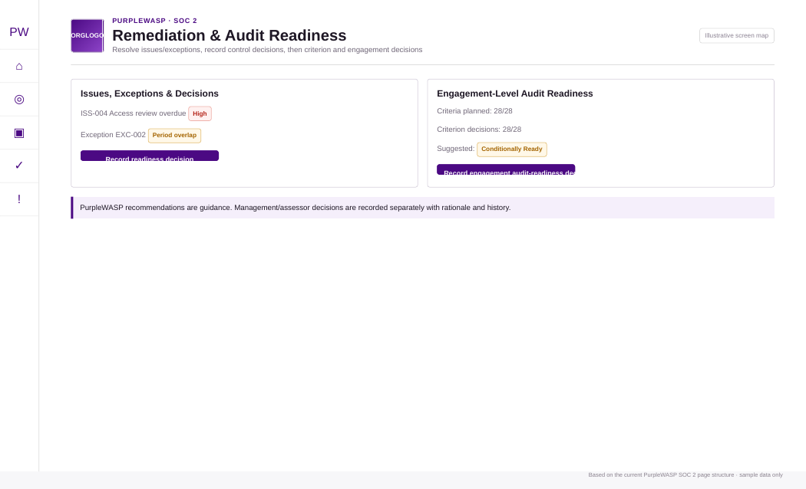
Figure 12. Illustrative remediation and engagement-level audit readiness workspaces.

18.1 Create and manage issues
Field | Purpose
Issue title / description | Describe the control problem or observation clearly.
Severity | Low, Medium, High or Critical under the current fallback schema.
Status | Current fallback states include Open, In Progress, Blocked, Resolved, Accepted and Closed.
Source | May identify Manual, Assessment, Test, Evidence or System where supported.
Scoped asset | Tie the issue to a specific asset where appropriate.
Owner | Assign remediation accountability.
Detected / identified at | Record when the problem was identified.
Remediation due | Set the expected correction deadline.
Resolution / remediation notes | Document what changed and the basis for closure/acceptance.

18.2 Request and manage exceptions
Field | Purpose
Exception title / reason | State exactly what normal control requirement or operation is being excepted and why.
Business justification | Explain why the exception is necessary and acceptable.
Status | Current fallback states include Requested, Approved, Rejected, Expired, Revoked and Closed.
Valid from / Expires at | Define the exception window.
Next review | Schedule formal reconsideration.
Related risk | Select an existing Risk Management register item; PurpleWASP stores the numeric register key while showing code/title.
Compensating control / safeguard | Describe the mitigation that reduces risk while the exception exists.
Compensating organisation control | Select an existing Control Management control; a control cannot select itself as its compensating control.

Type II exception visibility
Approved exceptions that overlap the observation period remain visible even if they later expire. That historical period overlap can still matter to the service auditor.

18.3 Record the control readiness decision
PurpleWASP calculates a suggested state from implementation, assessment, evidence, testing, issue and exception signals. The suggestion is guidance only. The user records a separate engagement-specific decision with rationale and optional conditions/follow-up. A later decision supersedes the previous current row and preserves history.
Decision | Use it when
Ready | Management/assessor concludes the selected control is ready for the intended examination and no known blocker contradicts that conclusion.
Conditionally Ready | The control can proceed subject to specific documented conditions/follow-up.
Not Ready | A material unresolved blocker means the control should not be treated as audit ready.
Review Required | The available information is insufficient or needs management/assessor review before a final readiness conclusion.

19. Engagement-Level Audit Readiness
Goal: roll selected-control readiness up to the criterion level and then to a final engagement-level management/assessor conclusion. Candidate mappings that management has not selected remain advisory and do not enter the audit-readiness conclusion.

19.1 Engagement readiness gates
- Applicable criteria must have a coverage plan before a Ready/Conditionally Ready engagement conclusion can be recorded.
- Current criterion decisions are expected for all applicable criteria before the final engagement conclusion is treated as complete.
- A criterion cannot be marked Ready/Conditionally Ready when a selected control has a current Not Ready decision.
- The engagement cannot be marked Ready unless every applicable criterion decision is Ready.
- A Conditionally Ready engagement cannot contain a current Not Ready criterion decision.

19.2 Review category roll-up
The category roll-up groups criterion outcomes under the selected Trust Services Categories so management can see whether one category is driving most remaining work.

19.3 Record criterion decisions
1. Open a criterion. Criteria without a coverage plan are collapsed by default; criteria with selected controls/current decisions can remain open.
2. Review the PurpleWASP recommendation and the selected-control details. Use the reason text to understand the current signal.
3. Choose Record/Update criterion decision. The editor opens in the SOC 2 modal workspace.
4. Choose Ready, Conditionally Ready, Not Ready or Review Required. The write path blocks unsupported Ready/Conditional conclusions where hard blockers exist.
5. Write decision rationale. Explain why management/assessor agrees with or departs from the recommendation.
6. Write Conditions / follow-up where applicable. This is especially important for Conditionally Ready.

19.4 Record the engagement decision
After criterion decisions are complete, use the final Management / assessor audit-readiness decision. This decision does not modify the underlying controls, criteria, evidence, tests, issues or exceptions. It is a snapshot conclusion. Later decisions supersede the current row while preserving history.
Readiness is not the auditor opinion.
A PurpleWASP engagement decision of Ready means management/assessor believes the current evidence and control state are ready to enter the examination. The service auditor can still identify exceptions, request more evidence, alter sampling or reach a different examination conclusion.

20. Type I operating playbook
Use this playbook when the intended examination is Type I: design of controls at a specified date.
1. Confirm the service/system scope and as-of date. Make sure the system description and boundary are accurate for that date.
2. Complete criterion coverage. Every applicable criterion should have a defensible selected-control plan.
3. Document implementation. Focus on how the control is designed and in place as of the specified date.
4. Perform design assessments. Operating assessment/testing may still be useful internally, but Type I readiness fundamentally depends on design at the as-of date.
5. Collect evidence of design and implementation. Policies, configurations, approved procedures, architecture records, role assignments and point-in-time control artefacts should be traceable to the as-of date.
6. Resolve material issues. Do not assume a newly designed control is ready if implementation evidence shows it was not actually in place.
7. Record control and criterion readiness decisions. Use rationale that refers to the as-of state.
8. Prepare the service auditor handoff. Provide the confirmed boundary, system description inputs, control population, design evidence and any known exceptions.

21. Type II operating playbook
Use this playbook when the intended examination is Type II: design and operating effectiveness across an observation period. The biggest practical difference is that evidence and test timing become first-class concerns.
1. Choose a realistic observation period. Do not set a period that predates reliable control operation/evidence unless management and the service auditor have a clear plan for the resulting limitations.
2. Freeze the intended scope before the period where practical. Frequent scope changes during the period create explanation and evidence challenges.
3. Operate controls on their defined cadence. A quarterly review should actually happen each quarter; an annual policy control should follow its defined review cycle.
4. Collect evidence continuously. Do not wait until period end to reconstruct months of evidence.
5. Use source timestamps and validity intervals. PurpleWASP distinguishes the underlying evidence time from the date it was added to the platform.
6. Run control tests during the period. Record the real execution/completion timestamp and preserve run history.
7. Open issues when failures occur. Do not hide failed tests. Track remediation, retesting and any approved exception.
8. Monitor Operational Readiness throughout the period. Period-relevant evidence and in-period tests should grow as expected.
9. Before fieldwork, complete criterion and engagement decisions. Any Conditional/Not Ready outcome should have a clear remediation or disclosure plan.
10. Expect the service auditor to sample independently. PurpleWASP readiness does not restrict auditor procedures.
Evidence cadence recommendation
For recurring controls, collect evidence close to the control cadence rather than batching everything at the end. This reduces missing periods and makes test failures/remediation visible while there is still time to act.

22. Preparing for the service auditor

22.1 What PurpleWASP should be able to show
- The confirmed engagement snapshot: selected categories, system boundary, service description, intended users, report type/period, subservice treatment, CUECs and key judgements.
- The criterion population for the engagement and the management-selected control coverage for each applicable criterion.
- For every selected control: implementation status, owner, implementation statement and relevant asset-level implementation.
- Final assessment records with method, result, date, validity, coverage/confidence and notes.
- Linked evidence with source timestamps/validity and clear link purpose.
- Test definitions and run history with actual execution timestamps and results.
- Open/closed issues, approved/rejected exceptions, related risks and compensating controls.
- Control readiness decisions, criterion readiness decisions and the current engagement decision, including superseded history where relevant.

22.2 Build an auditor request index
Even if the final exchange occurs outside PurpleWASP, use PurpleWASP as the master index. For each auditor request, point back to the selected control, evidence record, test run, issue/exception and system-boundary object rather than uploading untracked duplicates into multiple places.
Auditor request column | Recommended value
Request ID | Auditor PBC/request-list identifier.
Criterion/control | PurpleWASP criterion code and organisation control code.
Evidence reference | Evidence title plus storage reference/external URL.
Period relevance | Why the artefact supports the as-of date or Type II observation period.
Owner | Person responsible for follow-up.
Status | Open / supplied / follow-up required / closed.
Exception/issue link | Any known limitation already tracked in PurpleWASP.

22.3 Do not oversell automation
Automated collection and readiness signals reduce manual work, but the service auditor still determines sufficient appropriate evidence, sample sizes, procedures and the final opinion. If PurpleWASP has an evidence item but the underlying source or completeness is unclear, treat that as a documentation problem rather than an automation success.

23. Example: first SOC 2 journey from zero to readiness
Example only
The company, system, dates and decisions below are fictional. They show how to think through the workflow; they are not a template that every organisation should copy.

Assume ExampleCloud operates a B2B SaaS platform. Customers ask for SOC 2 because the platform stores customer business data and is expected to be highly available. The company has never completed SOC 2 before.

23.1 Scope
1. Select Security. It is the baseline.
2. Select Availability. The contracts contain uptime and recovery commitments.
3. Do not select Processing Integrity, Confidentiality or Privacy solely because they sound important. The SOC 2 lead documents why they are not intended examination categories for this first report and confirms with the service auditor.
4. Select production operations, customer onboarding, access administration, incident response and change management as process anchors. Discovery returns production cloud accounts, identity provider, ticketing system, monitoring platform and several vendors.
5. Resolve the monitoring provider as an included third party with a specific supporting service. Management plans carve-out treatment and writes the rationale.
6. Set Type II for 1 January to 30 June. The target report date is later in the year.
7. Document CUECs. Customers must maintain authorised user lists and promptly remove access for terminated users.

23.2 Controls
The criteria workspace shows candidate governance, access, change, incident, vendor and availability controls. ExampleCloud adopts only controls it actually operates, then selects the smallest defensible control set that collectively covers the applicable criteria. Candidate controls that do not match the service are explicitly not used rather than silently ignored.

23.3 Implementation and evidence
For the quarterly access review control, the implementation statement identifies the identity platform, review owner, quarterly cadence, reviewer steps, approval record and remediation process. Evidence is linked for each quarter using the actual review/export date. A Combined assessment is finalised as Effective after the assessor reviews the procedure and a sample of completed reviews.

23.4 Testing and remediation
A quarterly access-review test is created. The Q1 run passes. Q2 finds one terminated user with delayed removal. The test run is recorded as Failed/exceptional, an issue is opened with High severity, remediation is assigned and a follow-up test is recorded after correction. Management does not delete the failed run; it preserves the history and explains the remediation.

23.5 Readiness
Operational Readiness initially shows the access control as needing attention because of the active issue. After remediation and retest, the control recommendation improves. Management records the control decision with rationale, then records criterion decisions. If one availability criterion still lacks sufficient in-period evidence, the engagement may remain Conditionally Ready until the final evidence arrives rather than forcing a Ready conclusion.

24. Recommended operating cadence
Cadence | SOC 2 lead activities | Control/evidence owner activities
Weekly during implementation | Review new blockers, unresolved scope/coverage decisions, overdue remediation and upcoming test/evidence deadlines. | Complete assigned implementation updates, evidence requests and issue actions.
Monthly during Type II period | Review Operational Readiness, period-relevant evidence growth, active exceptions, overdue tests and assessment validity. | Upload/link evidence from monthly controls and resolve failed control operation.
Quarterly | Review criterion coverage, quarterly control evidence, test results, third-party changes and scope changes. | Run quarterly tests/reviews and update implementation statements if procedures changed.
Before fieldwork | Run full readiness review, close or document material issues, complete criterion decisions and update the engagement decision. | Verify all PBC evidence references are accessible and period metadata is accurate.
After examination / major change | Retain history, review lessons learned, update the next engagement scope and control plan. | Update control design and evidence cadence for identified improvements.

25. Common mistakes and how to correct them
Mistake | Why it causes problems | Correction
Selecting every Trust Services Category | Expands criteria/evidence/testing without a clear stakeholder need. | Select optional categories only when the service commitments and intended examination justify them.
Treating candidate controls as coverage | Candidate mappings are advisory and may include controls the organisation does not operate. | Adopt relevant controls and explicitly select them in the Coverage Plan.
Writing a generic implementation statement | An assessor cannot understand who does what, where, how often or with what output. | Describe the organisation-specific operating process and systems.
Uploading evidence with no source date | The platform cannot reliably determine Type II period relevance. | Record the underlying event/source timestamp or validity interval.
Using upload date as proof of operation | A file uploaded today may describe an event months earlier or later. | Use evidence/source time and link purpose.
Recording a test today for an old run but using today as execution time | Makes the run appear to have occurred in the wrong period. | Record the actual completed/execution timestamp.
Deleting failed history | Removes the factual trail an auditor may expect to understand. | Preserve run/issue history and document remediation/retest.
Leaving exceptions open-ended | An exception without expiry/review becomes a permanent bypass. | Define validity, next review, related risk and compensating safeguard.
Forcing Ready despite blockers | Creates a management conclusion that contradicts underlying state; hard blockers may also be write-blocked. | Resolve the blocker or record Not Ready/Review Required/Conditional with defensible conditions.
Changing fundamental scope silently | Breaks the relationship between the confirmed snapshot and later control/evidence conclusions. | Treat material scope changes as a deliberate configuration update/new snapshot and align with the service auditor.

26. Troubleshooting and interpretation guide
Symptom | Likely reason | What to do
Dashboard says no confirmed engagement | Setup has not been confirmed. | Run the four-step Scope Setup workflow and pass the final validation gate.
Cannot confirm Step 4 | Blocking/review scope gaps, incomplete Step 3 fields, undecided CUECs/subservice treatment, invalid dates or missing rationale. | Return to the section named in the validation message; do not bypass it.
Control appears as candidate but cannot be selected | It has not been adopted into Control Management. | Open Review / adopt, complete adoption, then return to Coverage Plan.
Cannot mark selected control Not Applicable | PurpleWASP blocks Not Applicable while the control is selected for SOC 2 coverage. | Remove/clear the coverage selection first if Not Applicable is genuinely correct.
Operational Readiness shows no selected controls | Coverage plan has not selected organisation controls. | Complete Control Coverage Plan; candidate mappings alone are not counted.
Evidence is Period relevant (historical) | The item overlaps the period but is no longer current. | Keep it for history, and link current support where the control requires current evidence.
Evidence says Temporal basis unknown | Source timestamp/validity is missing. | Correct the evidence metadata; do not rely on upload time.
Test run says Execution period unknown | Actual completion/execution timestamp is missing or unusable. | Enter the real execution timestamp.
Criterion cannot be marked Ready | No selected coverage or a selected control has a Not Ready current decision / recommendation blocker. | Fix coverage/control readiness before forcing the criterion conclusion.
Engagement cannot be marked Ready | Not all applicable criteria have current Ready decisions. | Complete criterion decisions and resolve Not Ready/Conditional states as required.
Old decision is no longer current | A later readiness decision superseded it. | Review history; this is expected behaviour and preserves the audit trail.

27. Master implementation checklist

27.1 Setup and scoping
[ ] Security baseline reviewed and optional categories justified.
[ ] Boundary-anchoring business processes selected.
[ ] Discovered assets reviewed.
[ ] Discovered third parties/services reviewed.
[ ] Scope-only items added where PurpleWASP source data is incomplete.
[ ] All blocking and management-review scope gaps resolved.
[ ] Service name, description and commitments completed.
[ ] Intended report users documented.
[ ] Type I or Type II selected; required dates complete.
[ ] Subservice organisation treatment and rationale completed.
[ ] CUECs explicitly Yes/No; complete CUECs documented if Yes.
[ ] Significant-changes decision complete.
[ ] Criterion-exclusion planning decision complete.
[ ] Step 3 completeness check passes.
[ ] Step 4 management attestation completed and engagement confirmed.

27.2 Controls and operation
[ ] Every applicable criterion reviewed in Criteria Workspace.
[ ] Relevant candidate controls adopted into Control Management.
[ ] Explicit coverage selection completed for every applicable criterion.
[ ] Selected controls have accurate applicability/requirement/implementation status.
[ ] Control and implementation owners assigned.
[ ] Implementation statements describe real operation.
[ ] Asset-specific implementation recorded where material.
[ ] Appropriate final assessments completed.
[ ] Assessment notes explain procedures, evidence and limitations.

27.3 Evidence, testing and remediation
[ ] Evidence linked to every selected control as appropriate.
[ ] Evidence source timestamps/validity dates are accurate.
[ ] Type II evidence has sufficient observation-period relevance.
[ ] Test plans exist for controls requiring testing/monitoring.
[ ] Test procedures and expected results are documented before execution.
[ ] Actual test execution timestamps are recorded.
[ ] Failed/error/inconclusive runs remain visible and are investigated.
[ ] Issues are created for material control failures/gaps.
[ ] Exceptions have justification, validity/review dates, risk and compensating safeguards where applicable.

27.4 Readiness and auditor preparation
[ ] Operational Readiness reviewed across all selected controls.
[ ] Control readiness decisions recorded with rationale.
[ ] Every applicable criterion has a current decision.
[ ] No selected control Not Ready blocker contradicts a Ready/Conditional criterion decision.
[ ] Engagement readiness decision recorded.
[ ] PBC/auditor request index prepared using PurpleWASP references.
[ ] Known exceptions and unresolved limitations are disclosed rather than hidden.
[ ] Current engagement snapshot, evidence links and owners are accessible for fieldwork.

28. Glossary
Term | Meaning
AICPA | American Institute of Certified Public Accountants; publisher of the SOC framework and Trust Services Criteria.
Applicable criterion | A Trust Services criterion included in the confirmed engagement and not treated as not applicable.
Candidate control | A PurpleWASP mapping suggesting that a control may support a criterion; not yet an organisation coverage decision.
Coverage plan | Management-selected criterion-to-organisation-control relationships used for readiness calculations.
CUEC | Complementary User Entity Control - a responsibility expected of the user entity/customer.
Design effectiveness | Whether the control is suitably designed to meet its objective/criterion.
Evidence link | The relationship between a reusable evidence record and an organisation control.
Inclusive method | SOC reporting treatment in which relevant subservice-organisation controls are included in the description/examination, subject to auditor judgement and applicable requirements.
Carve-out method | SOC reporting treatment in which the description identifies the subservice organisation but its controls are excluded from the scope of the service auditor’s examination, subject to auditor judgement and applicable requirements.
Observation period | The period over which Type II operating effectiveness is examined.
Operating effectiveness | Whether a control operated as designed over the relevant time/population.
Period-relevant evidence | Evidence whose source or validity interval overlaps the engagement observation window under PurpleWASP’s temporal classification.
Readiness recommendation | PurpleWASP-derived guidance from current operational signals.
Readiness decision | Management/assessor conclusion stored separately from the recommendation and preserved with rationale/history.
Service auditor | The independent CPA/practitioner performing the SOC 2 examination and issuing the report.
SOC 2 Type I | Examination of control design at a specified date.
SOC 2 Type II | Examination of control design and operating effectiveness over a period.
Subservice organisation | A service provider whose services/controls may be relevant to the service organisation’s system and the applicable criteria.
Trust Services Categories | Security, Availability, Processing Integrity, Confidentiality and Privacy.
Trust Services Criteria | AICPA criteria used to evaluate controls relevant to the selected Trust Services Categories.

29. PurpleWASP page reference
User-facing page | Route | Use
SOC 2 Dashboard | /compliance/soc2/dashboard | Engagement summary and live readiness overview.
Scope Setup | /compliance/soc2/setup | Four-step setup modal/workspace.
System Scope | /compliance/soc2/system_scope | Step 2 boundary discovery (normally opened inside setup).
Engagement Scope | /compliance/soc2/engagement_scope | Step 3 engagement/system description (normally opened inside setup).
Review & Confirm | /compliance/soc2/review_confirm | Step 4 final validation/confirmation (normally opened inside setup).
Criteria Workspace | /compliance/soc2/criteria_workspace | Criteria and candidate/selected control matrix.
Control Coverage Plan | /compliance/soc2/control_coverage | Explicit management coverage selections.
Implementation Workbench | /compliance/soc2/control_implementation | Control and asset implementation.
Control Assessments | /compliance/soc2/control_assessment | Design/operating/combined assessment records.
Tests & Monitoring | /compliance/soc2/control_testing | Test definitions and completed runs.
Evidence | /compliance/soc2/evidence | Evidence creation/linking and temporal classification.
Operational Readiness | /compliance/soc2/operational_readiness | Selected-control readiness signals.
Issues, Exceptions & Decisions | /compliance/soc2/issues_exceptions | Remediation, exceptions and control readiness decisions.
Audit Readiness | /compliance/soc2/audit_readiness | Criterion and engagement readiness conclusions.

30. References
PurpleWASP implementation basis
- Current SOC 2 Core v1 application pages and shared workspace UI supplied for this documentation.
- PurpleWASP SOC 2 Core v1 Consolidation & UI Hardening notes and regression checklist included in the current build.
Authoritative external references
- AICPA & CIMA - System and Organization Controls: SOC Suite of Services
- AICPA & CIMA - 2017 Trust Services Criteria (With Revised Points of Focus - 2022)
- AICPA & CIMA - SOC for Service Organizations Engagements - Overview (2026)
- AICPA & CIMA - SOC 2 Reporting on an Examination of Controls at a Service Organization Relevant to Security, Availability, Processing Integrity, Confidentiality, or Privacy
Copyright and criteria text
This guide intentionally explains the workflow and categories without reproducing the full copyrighted Trust Services Criteria or the full SOC 2 Description Criteria. Use the current AICPA publications when exact authoritative criterion wording is required.

Current AICPA basis noted for this edition
At the time this guide was prepared (September 2026), AICPA & CIMA continued to list the 2017 Trust Services Criteria with revised points of focus (2022) and the 2018 SOC 2 Description Criteria with revised implementation guidance (2022) in its SOC resource library. Always confirm the current authoritative criteria and professional standards with your service auditor before beginning a new examination period.
End of guide
Use PurpleWASP to preserve the operational trail; use professional judgement and the service auditor to determine the final SOC 2 examination scope and evidence requirements.

